**To complete this activity, perform the following steps:**

1. Open the folder in VS Code and access the app.py file. Complete the code following the instructions in the commented line. Your application should display the “My first GET *request*” in a browser window.
   1. Provide two screenshots, one of your modified code in VS Code and one of your browser window displaying the line above.
2. Modify the app.py file so that it includes HTML code to display the line “My first GET *request*” in a browser window. Run and debug your code. Ensure that the line “My first GET *request*” is displayed correctly in HTML in the browser window.
   1. Provide two separate screenshots in your submission file, one of your modified code in VS Code and one of your browser window displaying the line “My first GET *request*” in HTML.
3. Open the file index.html in the template folder and include the correct HTML code so that your browser window displays the text “Hello, my name is <your_full_name>”.
   1. Provide a screenshot in your submission file.
4. Edit the app.py file by modifying the *decorator* app_route() to render the HTML template.
   1. Provide a screenshot in your submission file.

**Submission Instructions:**

In your submission, include a .zip file containing the code you modified to accomplish the steps in the activity. In the .zip file, also include a Word document with all the screenshots that you took to demonstrate your completion of the activity. Be sure to number your screenshots as listed below:

1. One screenshot of your modified code in VS Code and one screenshot of your browser window displaying the line: “My first GET *request*”.
2. One screenshot of your modified code in VS Code and one screenshot of your browser window displaying the line “My first GET *request*” in HTML.
3. One screenshot of your browser window displaying the line: “Hello, my name is <your_full_name>”.
4. One screenshot demonstrating successful editing of the app.py file by modifying the *decorator* app_route().
5. Open the folder in VS Code and access the app.py file. Complete the code following the instructions in the commented line. Your application should display the “My first GET *request*” in a browser window.
   1. VS Code screenshot:

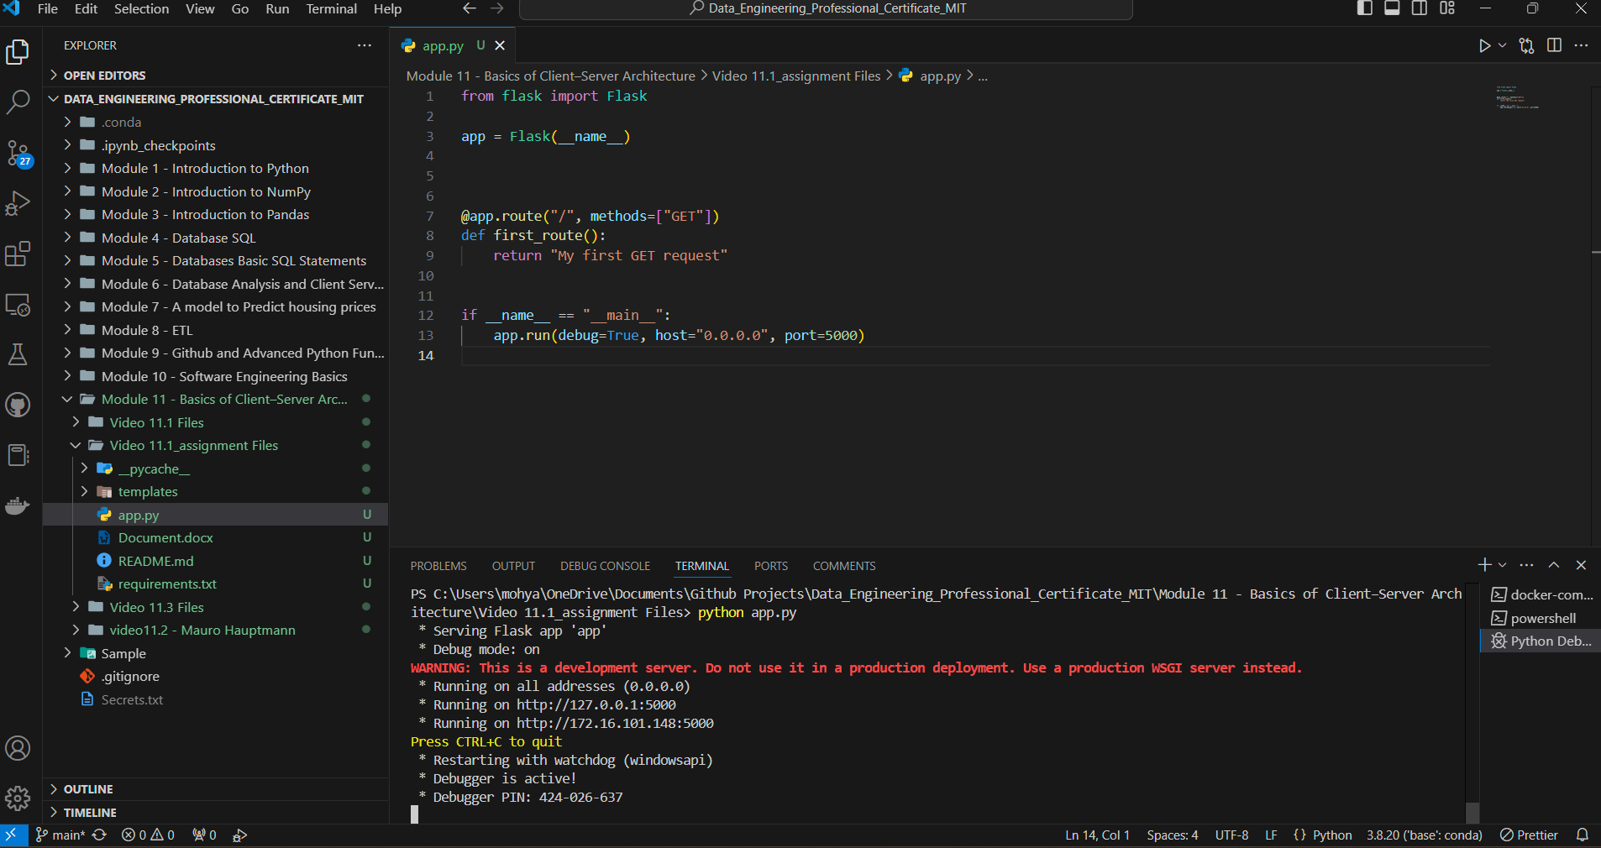

* 1. Localhost:5000

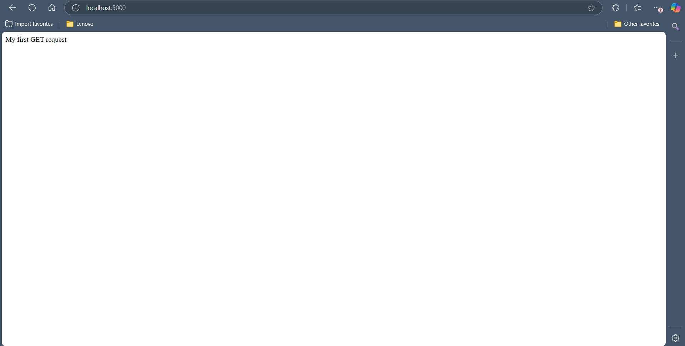

1. Modify the app.py file so that it includes HTML code to display the line “My first GET *request*” in a browser window. Run and debug your code. Ensure that the line “My first GET *request*” is displayed correctly in HTML in the browser window.
   1. VS Code:

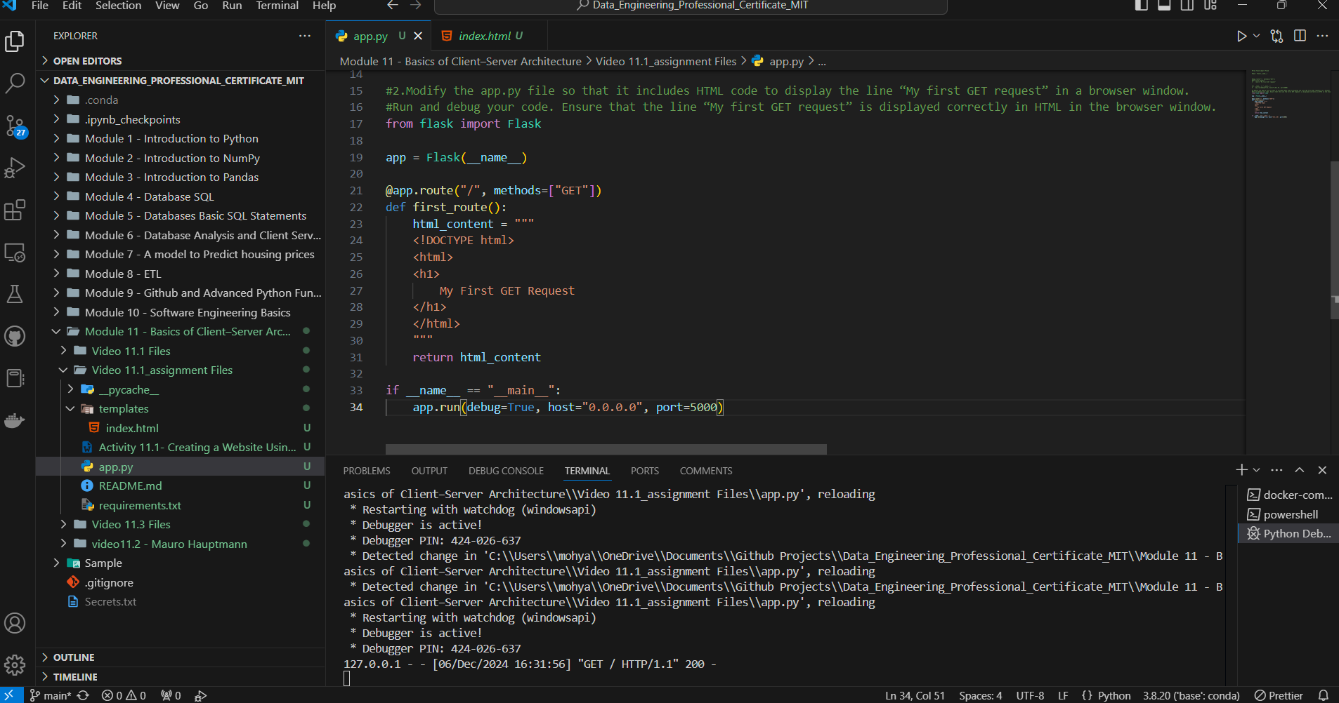

* 1. Localhost:5000

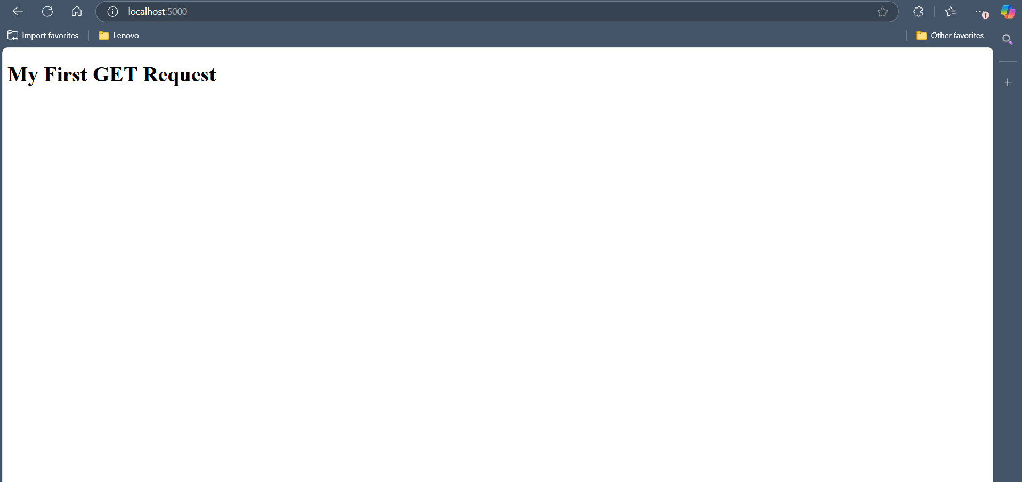

1. Open the file index.html in the template folder and include the correct HTML code so that your browser window displays the text “Hello, my name is <your_full_name>”.
   1. VS Code:
      1. Index.html

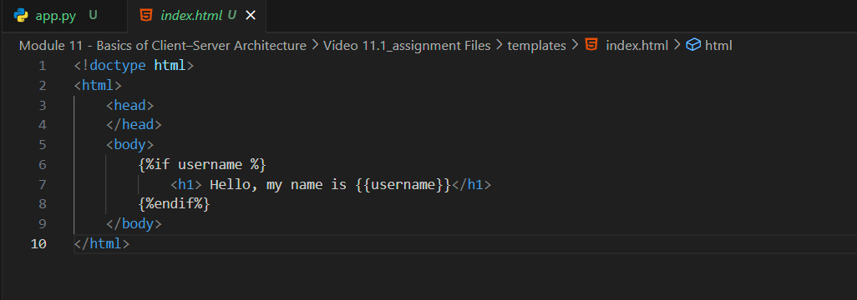

1. Edit the app.py file by modifying the *decorator* app_route() to render the HTML template.
   1. VS Code:
      1. App.py:

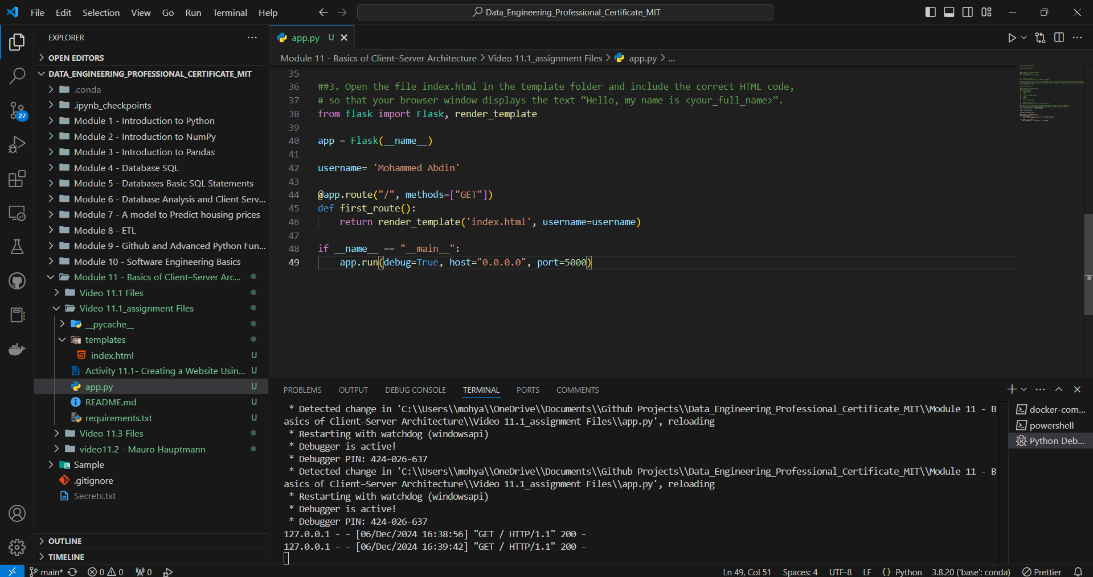

* 1. Localhost:5000

